LeadMinds Company Profile

LeadMinds
Empowering Minds.. To Lead Transformation..
Professional HR Certification Preparation | Specialized Programs | Strategy Activation & Performance Alignment | Leadership Development | Executive Coaching & Mentorship
Beyond Training. Toward Real Capability.

Established through a trusted network of experts bringing together over 130 years of combined practical experience in human capital, HR certification preparation, leadership development, strategy execution, executive coaching, assessment, and organizational capability building.

Founders' Message

"At LeadMinds, we believe that sustainable business growth and economic prosperity fundamentally rely on empowering individuals and organizations, while elevating the professional efficiency of human capital. In alignment with the Kingdom’s ambitious vision to adopt global best practices, LeadMinds is committed to delivering qualitative training solutions. We seamlessly blend deep field expertise with the latest accredited standards for international professional certifications to qualify individual talents and develop organizational capabilities—forging a true partnership that guarantees your professional excellence and sustainable success."

Company Overview

LeadMinds was established to be the leading strategic partner in the training and development sector. We deliver innovative training solutions that meet the aspirations of individuals and organizations alike, contributing to building sustainable capabilities that drive impact and excellence in modern work environments.
We are committed to empowering individuals and organizations to achieve their strategic goals, drive transformation, and make a tangible difference by focusing on five core areas that define our services:
- Preparation for International Professional Certifications: Empowering trainees to successfully obtain professional credentials in Human Resources.
- Specialized Programs: Providing advanced developmental solutions in Human Resources, management, and organizational development.
- Strategy Activation & Performance Alignment: Aligning human capabilities with corporate and strategic objectives.
- Leadership Development: Building influential professional leaders capable of effective decision-making and leading organizational change.
- Executive Coaching & Career Guidance: Delivering tailored, advanced coaching and guidance for executives and leaders.

Corporate Identity Card (Info-graphic)
Pillar | Details
Nature of Business | A leading institute specialized in international professional certifications and qualitative training.
Core Expertise | Capability building, development of behavioral, technical, and leadership skills, strategy activation, and performance alignment.
Geographic Scope | Delivering professional services both within and outside the Kingdom of Saudi Arabia.
Target Sectors | Government and semi-government entities, as well as large, medium, and startup companies.
Target Audience | Employees, managers, executive leaders, and all professionals seeking continuous career development.

Strategic Alignment with Saudi Vision 2030

LeadMinds aligns its vision and strategic goals with the Kingdom’s directives toward human capability development, enhancing workforce readiness, and optimizing institutional performance as core pillars of Saudi Vision 2030.
Through our integrated suite of services, we empower national talents to apply global standards tailored to the dynamic realities and demands of the Saudi and Gulf markets.
Our strategic contribution focuses on the following Vision 2030 Objectives: (Info-graphic)
- Human Capital Development: Elevating the capabilities and readiness of HR professionals in accordance with top international benchmarks.
(Aligned with Strategic Objective 4.1.5: Develop brightest minds and talents in priority fields).
- Promoting Continuous Learning: Fostering a culture of sustainable self-development and constant professional readiness to keep pace with market shifts.
(Aligned with Strategic Objective 4.1.1: Build a life-long learning and development journey).
- Empowering Administrative Leadership: Equipping leaders and managers to execute strategies with clarity and drive organizational transformation effectively.
(Aligned with Strategic Objective 4.2.1: Improve readiness of workforce and youth to enter and lead the labor market).
- Building Institutional Capabilities: Supporting organizations in developing robust, sustainable, and scalable internal capabilities to maximize efficiency.
(Aligned with Strategic Objective 5.1.1: Enhance corporate capability building and performance of institutions).
- Aligning Learning with Market Demands: Bridging the gap between developmental programs and actual labor market needs to maximize workplace performance.
(Aligned with Strategic Objective 4.1.6: Ensure alignment of qualification and training outputs with labor market needs

Key Capability Indicators(Info-graphic)
- Built on over 130 years of combined practical expertise through our expert network.
- HR certification preparation experience in Saudi Arabia since 2012.
- Supported more than 1000 HR professionals and HR leaders in their certification journeys.
- Extensive experience in preparing candidates for exams for SHRM-CP, SHRM-SCP, aPHRi, PHRi, and CIPD Level 3 & 5 certifications.
- More than 45,000 hours of training and leadership development experience.
- More than 120 assessment and development centers designed and delivered.
- Experience serving leading organizations across Saudi Arabia and the GCC.

Vision, Mission, and Values

Vision
To shape and lead minds toward sustainable excellence by transforming potential into capabilities, and capabilities into tangible results, through integrated human capital development solutions.
Mission
We invest our global expertise to create a sustainable local impact by empowering minds and leading organizational transformation, committed to integrity and excellence in execution to deliver exceptional results for our clients.

Values (Info-graphic)

Uncompromising Integrity: We operate with absolute transparency and rigorous ethical oversight. We serve as a trusted advisor, prioritizing confidentiality, fairness, and strict compliance in every professional engagement.

Agility & Resilience: We adapt swiftly and efficiently to the evolving dynamics of the business sector, turning challenges into premium opportunities. By embracing flexible practices and innovative solutions, we ensure continuous success and sustain long-term impact for our clients under any circumstances.

Excellence in Execution: Every initiative we undertake is driven by a rigorous and structured methodology. This ensures complete transparency, unwavering accountability, and high-impact, measurable results across all our engagements.

Why Choose LeadMinds

- Practitioner Experts, Not Just Academics: We believe that true knowledge comes from the field. Therefore, our programs are designed and led by practitioner experts with a proven track record and extensive experience in leading HR sectors and developing corporate governance, transferring their real-world expertise, practical experiences, and actual labor market challenges directly to you.
- Real-World Simulation & Full Exam Readiness: We go beyond theoretical explanation to empower you and maximize your readiness to pass international exams. We provide an advanced simulation environment that includes interactive question banks and mock exams, placing you in the actual test atmosphere and supporting your career excellence.
- Quality (Global Standards & High Reliability): We are committed to delivering educational and training content that aligns with the most precise and up-to-date international standards, creating a rich experience that combines rigorous knowledge with seamless practical application to meet your aspirations.
- Investment & Impact (Tangible Return & Sustainable Change): The design of our programs centers on achieving the highest Return on Investment (ROI) for individuals and organizations. We focus on skills that translate directly into improving institutional performance, leaving a positive and sustainable impact that extends throughout your career path and business outcomes.

Qualification Programs for International Professional HR Certifications

Qualification for international professional HR certifications represents one of LeadMinds’ strongest core pillars. International professional certifications are globally recognized credentials and accreditations that accelerate professional efficiency, elevate competence, and advance practitioners' career paths. Our training programs serve as preparatory and qualifying bootcamps designed to enable practitioners to master approved global HR standards, guided by the most prominent international professional models and certifications offered globally (including, but not limited to) :
- SHRM-CP | (SHRM Certified Professional): Certified HR Professional from the Society for Human Resource Management (USA).
- PHRi | (Professional in Human Resources - International): International HR Professional Certification from the HR Certification Institute (USA).
- sHRBP | (Strategic Human Resource Business Partner): Strategic HR Business Partner Certification from the Human Capital Institute.
- SPHRi | (Senior Professional in Human Resources - International): International Senior HR Professional Certification from the HR Certification Institute (USA).
- CHRM | (Certified Human Resource Manager): Certified HR Manager from the American Certification Institute.
Within this framework, we offer an integrated series of preparatory programs under the title (HRi Pro). This series is specifically designed as a qualifying methodology aligned with the bodies of knowledge of leading international organizations such as SHRM, HRCI, HCI, and ACI, aiming to develop the competence of professionals and advance them through three progressive levels:

🎯 Available Training Course Levels:
- HRi Pro - Foundation Level: A comprehensive 50-hour training program aimed at building a solid knowledge base for beginners in the field, preparing them to grasp the fundamentals and scope of foundational exams, such as the (aPHRi) certification and others.
- HRi Pro - Practitioner Level: An advanced 60-hour training program that focuses on operational aspects and globally approved professional practices. It is the ideal preparation for those targeting professional and mid-level exams, such as (PHRi) or (SHRM-CP).
- HRi Pro - Strategic Leader Level: A leadership-focused 70-hour training program that zeroes in on analytical skills, strategic leadership, change management, and organizational development. It aims to provide final preparation for the challenges of senior international certification exams, such as (SPHRi), (SHRM-SCP), and others.
Historically, our network of experts has achieved a success rate exceeding 80% in preparation journeys for professional HR certifications. However, LeadMinds does not guarantee passing any exam, as results ultimately depend on each participant's commitment, prior experience, study effort, readiness, and the requirements of the certifying body.

📌 Clarifying Disclaimer (Intellectual Property Rights):
"LeadMinds" is committed to the highest standards of transparency and professionalism. Therefore, please note that all training programs and materials provided are independent, innovative qualification and preparatory programs developed by our experts to cover the professional competencies required in the labor market. All titles, acronyms, and trademarks belonging to international organizations (such as SHRM, HRCI, HCI, ACI) are the exclusive intellectual property of their respective awarding bodies. There is no official affiliation, sponsorship agreement, or exclusive alliance between "LeadMinds" and these institutes or organizations; our role is strictly limited to knowledge development and professional empowerment to help candidates successfully pass these exams.

Why Independent Preparation?
Independence gives LeadMinds the flexibility to prepare HR professionals with a wider, more practical view of the profession.
We are not tied to one certification body or one learning system. This allows us to connect global HR standards with practical application in the Saudi and GCC workplace.
Our approach combines:
- The strategic mindset needed for modern HR.
- The technical understanding required for certification exams.
- The practical application needed in real workplaces.
- The confidence-building support required before sitting for the exam.
We do not claim to be an official or approved center unless this is clearly documented. Instead, we position ourselves as an independent, expert-led preparation partner focused on readiness, confidence, and applied capability.

Specialized Programs

Our specialized training programs are designed to empower HR professionals and administrative leaders to transition from traditional operational roles to contributing effectively as strategic and trusted business partners.
We offer an integrated suite of qualitative programs covering human resource management, administrative systems, and organizational development. Each program is practical, focused, and built entirely around the real-world challenges faced by organizations today.

1. Strategic HR & Business Partnership

📑 HR Business Partnership Excellence
- What it builds: The ability to partner with business leaders, understand their needs, and provide practical people solutions.
- Who benefits: HRBPs, HR managers, talent managers, and senior HR professionals.
- Result: Stronger HR credibility, better stakeholder partnership, and more business-aligned HR decisions.

📑 Influencing & Consulting Skills for HR Professionals
- What it builds: The ability to influence, advise, manage stakeholders, and lead professional conversations.
- Who benefits: HR professionals who work closely with business leaders and internal clients.
- Result: Higher influence, clearer recommendations, and stronger advisory presence.

📑 HR Analytics for Decision-Making
- What it builds: The ability to read people data and turn it into useful insights.
- Who benefits: HR teams, HRBPs, talent professionals, and HR leaders.
- Result: Better workforce decisions, stronger planning, and more evidence-based HR practice.

📑 ESG for HR Professionals
- What it builds: Understanding of HR’s role in culture, wellbeing, inclusion, governance, sustainability, and responsible people practices.
- Who benefits: HR leaders, HRBPs, culture teams, organizational development professionals, and sustainability contributors.
- Result: Better alignment of HR policies and people practices with national sustainability priorities and global ESG reporting expectations.

2. Talent Acquisition & Management

📑 Mastering Competency-Based Interviewing
- What it builds: The ability to ask better questions, collect evidence, and make fairer selection decisions.
- Who benefits: Recruiters, hiring managers, HRBPs, and talent acquisition teams.
- Result: Better hiring decisions, reduced bias, and stronger quality of hire.

📑 Employer Branding for HR Professionals
- What it builds: The ability to strengthen the organization’s image as an employer and improve candidate and employee experience.
- Who benefits: HR, talent acquisition, communications, and employee experience teams.
- Result: Stronger attraction, better candidate experience, and improved employer reputation.

📑 Talent Assessment Center Design & Implementation
- What it builds: The ability to design and run structured assessment centers using competencies, tools, simulations, and clear evidence.
- Who benefits: Talent management teams, HR leaders, assessors, and OD professionals.
- Result: More objective talent decisions and clearer development priorities.

📑 Excellence in Talent Management
- What it builds: A complete approach to identifying, developing, retaining, and preparing talent for future roles.
- Who benefits: HR leaders, talent managers, succession planning teams, and business leaders.
- Result: Stronger talent pipelines, better succession readiness, and improved retention.

3. Performance & Culture

📑 Performance Systems Design & OKRs
- What it builds: The ability to design performance systems that connect goals, measures, accountability, and results.
- Who benefits: HR leaders, performance teams, managers, and strategy teams.
- Result: Clearer goals, stronger accountability, and better performance conversations.

📑 Building a High-Performance Organizational Culture
- What it builds: The ability to shape behaviors and practices that support accountability, collaboration, and sustained performance.
- Who benefits: Leaders, HR teams, OD teams, and culture champions.
- Result: Stronger ownership, better collaboration, and a healthier performance culture.

📑 The Effective Manager: People Management Essentials
- What it builds: The ability to lead people, give feedback, manage performance, and handle daily management situations.
- Who benefits: New managers, supervisors, team leaders, and middle managers.
- Result: More confident managers, better team communication, and improved people management.

4. HR Operations & Service Delivery

📑 Excellence in HR Operations & Service Delivery
- What it builds: The ability to improve HR services, simplify processes, enhance employee experience, and strengthen compliance.
- Who benefits: HR operations teams, shared services teams, HR managers, and employee experience teams.
- Result: Faster service, better employee experience, and more reliable HR operations.

Strategy Activation & Performance Alignment (Training & Implementation)

A strategy only delivers value when people understand it, embrace it, and execute it. LeadMinds helps leaders and teams translate strategy into clear priorities, KPIs, OKRs, action plans, and follow-up mechanisms.

1. Strategic Business Planning & Execution
- What the program builds: The capability to transform strategy into priorities, initiatives, key performance indicators, and an execution rhythm.
- Who benefits: Executives, heads of departments, managers, and strategy teams.
- The Outcome: Clearer direction, stronger alignment, and better execution discipline.

2. Translating Strategy into Real Action
- What the program builds: The ability to transition from high-level strategic discussions to ownership, milestones, and actionable plans.
- Who benefits: Leadership teams, PMOs (Project Management Offices), strategy teams, and business unit leaders.
- The Outcome: Reduced strategic ambiguity and enhanced accountability and execution.

3. KPI Design & Performance Alignment
- What the program builds: The capability to design meaningful KPIs and effectively link them to business outcomes.
- Who benefits: Managers, strategy teams, HR teams, PMOs, and performance teams.
- The Outcome: Improved measurement, clearer accountability, and a sharper focus on performance.

4. Balanced Scorecard (BSC) Essentials
- What the program builds: A practical understanding of strategy maps, perspectives, measures, targets, and initiatives.
- Who benefits: Strategy professionals, HR leaders, business managers, and performance teams.
- The Outcome: Better translation of strategy and a clearer structure for the performance management system.

5. Objectives & Key Results (OKRs) for Leaders & Teams
- What the program builds: The ability to set focused objectives and measurable key results.
- Who benefits: Leaders, managers, cross-functional teams, strategy teams, and project teams.
- The Outcome: Sharper focus, stronger alignment, and greater accountability.

.

Leadership Development

Leadership is not only about position. It is about behavior, influence, clarity, and the ability to help others perform.
LeadMinds develops leaders and managers through practical programs that focus on real leadership situations, workplace conversations, team performance, and decision-making.

Leading High-Performance Teams
What it builds: The ability to align, motivate, and enable teams to deliver stronger results.
Who benefits: Team leaders, managers, department heads, supervisors, and emerging leaders.
Result: Better team alignment, stronger motivation, clearer ownership, and improved performance.

Leadership Communication & Influence
What it builds: The ability to communicate clearly, influence stakeholders, manage difficult conversations, and create alignment.
Who benefits: Managers, leaders, HRBPs, project leaders, and client-facing professionals.
Result: Clearer communication, stronger influence, better stakeholder alignment, and more confident leadership presence.

Coaching Skills for Managers
What it builds: The ability to coach team members, unlock potential, support ownership, and guide performance improvement.
Who benefits: Managers, supervisors, team leaders, HR professionals, and talent development teams.
Result: Better development conversations, stronger employee ownership, improved performance, and healthier manager-employee relationships.

Decision-Making & Problem Solving for Leaders
What it builds: The ability to analyze situations, evaluate options, manage complexity, and make sound decisions.
Who benefits: Managers, leaders, supervisors, high-potential employees, and project owners.
Result: Better judgment, clearer decisions, stronger problem-solving, and reduced dependency on escalation.

Performance Conversations for Managers
What it builds: The ability to conduct constructive performance discussions, provide feedback, and address performance gaps professionally.
Who benefits: Managers, supervisors, HRBPs, performance management teams, and people leaders.
Result: Better feedback, clearer expectations, stronger accountability, and improved employee performance.

Executive Coaching & Mentorship
Coaching and mentorship create space for leaders and professionals to reflect, make better decisions, and grow with clarity.
LeadMinds supports leaders, HR professionals, and emerging managers through focused coaching and mentorship journeys that combine practical guidance, career direction, and leadership development.

Executive Coaching for Senior Leaders
What it builds: Self-awareness, strategic clarity, decision quality, leadership presence, and executive effectiveness.
Who benefits: Senior leaders, executives, directors, general managers, and high-potential leaders.
Result: Stronger leadership presence, clearer decisions, better influence, and improved executive confidence.

HR Career Mentorship
What it builds: Career clarity, certification direction, professional confidence, HR judgment, and stronger understanding of HR as a business function.
Who benefits: HR professionals, HRBPs, HR managers, certification candidates, and emerging HR leaders.
Result: Clearer career direction, better certification choices, stronger professional confidence, and more mature HR decisions.

Leadership Readiness Coaching
What it builds: Confidence, maturity, leadership mindset, role readiness, and ability to handle larger responsibilities.
Who benefits: Emerging leaders, succession candidates, newly promoted managers, and high-potential professionals.
Result: Smoother transition into bigger roles, stronger leadership confidence, and clearer readiness for future responsibilities.

Transition Coaching for New Managers
What it builds: The ability to shift from individual contribution to leading people, managing expectations, and delivering through others.
Who benefits: New managers, supervisors, first-time leaders, and recently promoted team leaders.
Result: Faster adjustment, clearer role understanding, better people leadership, and stronger early management performance.

Corporate & Government Training Solutions
We build and deliver integrated learning solutions for corporations and government entities through a practical methodology. Our approach bridges institutional needs with strategic goals, ensuring measurable results and a sustainable impact on both individual and organizational performance.

Our Solutions Include:(Info-graphic)
- Study Groups for HR Professional Certifications: Prep cohorts designed to qualify teams for global HR credentials.
- Establishing In-House HR Academies: Building internal academies to sustainably develop human resources capabilities.
- HR Business Partner (HRBP) Career Development Journeys: Structured growth tracks for HR business partners.
- Leadership Development Programs: Tailored initiatives to cultivate future and current leaders.
- Strategy Activation Workshops: Hands-on sessions to translate strategy into action.
- KPIs & OKRs Enablement Programs: Practical training to implement and drive performance frameworks.
- Manager Development Journeys: Comprehensive learning tracks to elevate managerial skills.
- Executive Coaching & Mentoring: One-on-one professional guidance for senior leaders.
- Assessment & Development Centers: Comprehensive evaluation setups to identify and nurture talent.
- Performance & Corporate Culture Programs: Initiatives designed to align workplace culture with performance goals.

Our Methodology: The LeadMinds Impact Framework

From Training Delivery to Measurable Capability
The LeadMinds Impact Framework is designed to ensure that every learning solution moves beyond content delivery and creates practical value in the workplace.
Our methodology is simple, structured, and focused on impact. It helps clients define the need, design the right learning journey, deliver practical experiences, support application, and measure what matters.

The LeadMinds Impact Framework

1. Understand
We start by understanding the organization’s goals, participant profiles, current capability gaps, and expected outcomes.
Outcome: Clear learning priorities and a focused development direction.

2. Design
We design a learning journey that fits the audience, business context, and desired capability outcomes.
Outcome: A relevant, practical, and fit-for-purpose learning experience.

3. Deliver
We deliver interactive and practical learning experiences using cases, discussions, tools, exercises, simulations, and guided practice.
Outcome: Stronger engagement, better understanding, and higher confidence.

4. Apply
We help participants apply tools, models, concepts, and techniques to realistic workplace situations.
Outcome: Learning moves from theory to practice.

5. Measure
We measure readiness, confidence, learning, application, and where possible, the practical impact of the program.
Outcome: Clearer evidence of progress and development value.

6. Sustain
We support continued growth through follow-up, coaching, mentoring, learning reinforcement, and practical action plans.
Outcome: Better continuity, stronger adoption, and sustained capability growth.

Success Stories & Case Studies

Practical Impact Across Certification, Leadership, and Strategy
LeadMinds’ expert network has contributed to capability-building journeys across HR certification preparation, leadership assessment and development, strategy activation, performance alignment, and professional mentoring.
The following case studies reflect the type of impact LeadMinds brings to professionals and organizations.

Case Study 1: HR Certification Readiness

Challenge
HR professionals needed structured preparation for international HR certification exams, while also developing practical HR judgment beyond memorization.

Solution
The expert network delivered preparation journeys that combined professional frameworks, exam practice, real HR examples, guided study planning, and mentoring support.

Impact
More than 1000 HR professionals and HR leaders were supported in their certification journeys, with historical success rates exceeding 80% across preparation programs delivered by the expert network.

Value Created
Participants gained stronger exam readiness, clearer professional judgment, and greater confidence in applying HR concepts in real workplace situations.

Case Study 2: Leadership Assessment & Development

Challenge
Organizations needed a more objective way to assess leadership readiness and support promotion, succession, and development decisions.

Solution
Assessment and development centers were designed using behavioral interviews, case studies, simulations, role plays, and structured evidence.

Impact
Organizations gained clearer insight into leadership strengths, development gaps, and readiness for future roles.

Value Created
Leaders received more focused development direction, while organizations improved the quality and objectivity of leadership decisions.

Case Study 3: Strategy Activation & Performance Alignment

Challenge
Leadership teams needed to turn strategy into clear priorities, measures, ownership, and action.

Solution
Strategy activation workshops helped teams clarify priorities, define KPIs and OKRs, assign ownership, and build follow-up routines.

Impact
Teams improved alignment, clarity, accountability, and execution discipline.

Value Created
Strategy became easier to understand, easier to communicate, and easier to follow through.

Case Study 4: Manager Capability Development

Challenge
New and middle managers often struggle with people leadership, feedback, performance conversations, and team ownership.

Solution
Practical manager development programs were delivered around leadership communication, coaching skills, performance conversations, decision-making, and team effectiveness.

Impact
Managers became more confident in handling daily leadership situations and more capable of supporting team performance.

Value Created
Teams experienced clearer expectations, better feedback, stronger ownership, and improved people management.

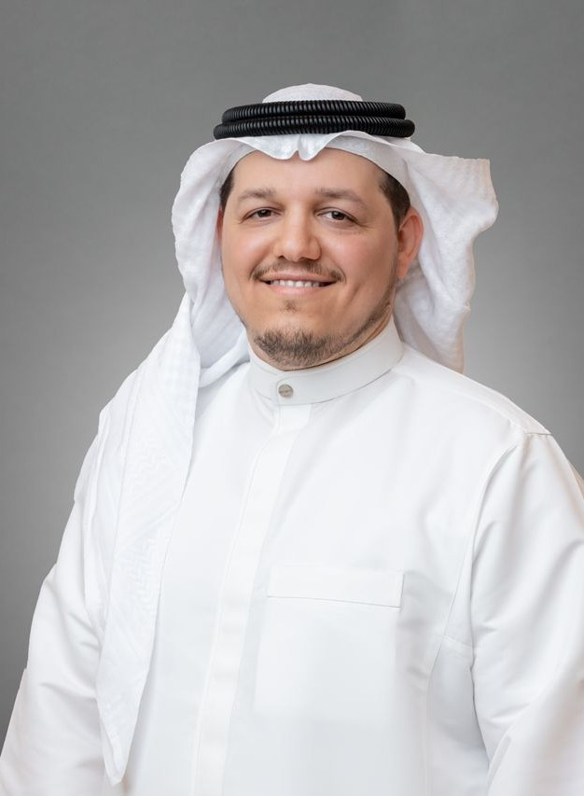

Abdul Elah Al-Ahmadi
Co-Founder | Managing Partner | HR Strategist & Corporate Governance Consultant
International & Professional Certifications: SHRM-CP / SPHRi / HRBP
Years of Experience: 17 years of leadership experience in HR management within the Saudi market.
A seasoned executive with extensive experience leading Human Resources and Corporate Governance functions across major Saudi groups and companies, including Al Murjan Holding Group, Goody, STC (Saudi Telecom Company), and Alhamrani Group of Companies.
He specializes in organizational design, developing delegation of authority matrices, designing HR processes, and drafting policies and procedures in alignment with global best practices. Additionally, he excels in developing workplace culture strategies, performance management, and establishing and managing corporate training academies.
Known for his ability to translate theoretical concepts, regulations, and bylaws into practical, actionable tools, he enables organizations to build agile, high-performing, and sustainable work environments.

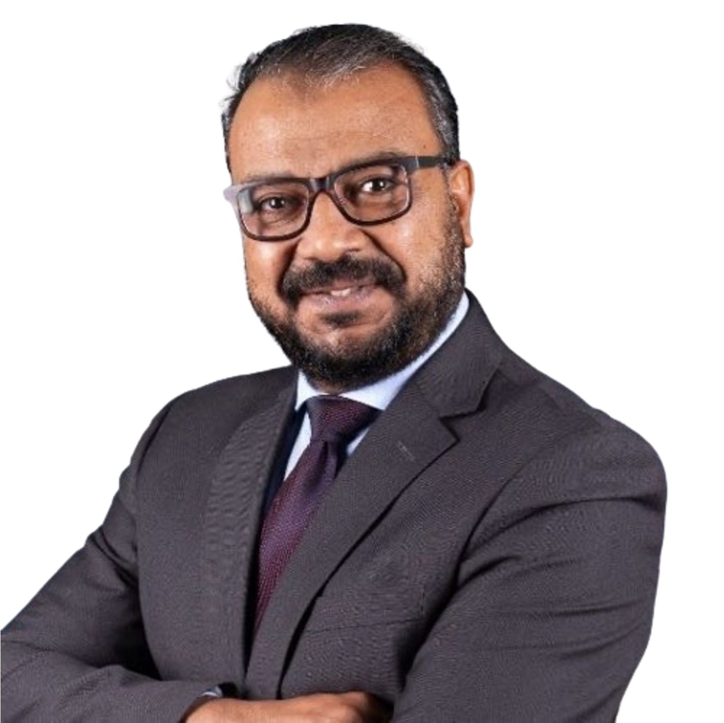

Essam Elbanna
Co-Founder | Managing Partner | Lead Consultant & Professional Mentor

Essam Elbanna is an HR consultant, executive coach, certified assessor, HR certification instructor, and professional mentor with more than 25 years of experience in HR transformation, leadership development, talent assessment, competency frameworks, performance management, and strategy execution.
He holds SHRM-SCP, SHRM-CP, and SPHRi credentials and has been delivering HR certification preparation programs in Saudi Arabia since 2012.
Essam was among the early HR leaders selected to participate in the pilot stage of SHRM certification exams and among the first certified professionals in the region.
Throughout his career, he has supported more than 1000 HR professionals and HR leaders in their certification journeys across SHRM, HRCI, and CIPD. He is also an instructor for CIPD Level 3 and Level 5.
Beyond instruction, Essam is known for his mentoring style. He helps HR professionals understand the profession, build confidence, develop judgment, and grow into stronger business partners and leaders.
His approach combines professional depth, practical examples, behavioral insight, and a strong understanding of the Saudi and GCC business context.

18. Faculty & Expert Trainers

The Right Expertise for the Right Capability
LeadMinds works with a selected network of trainers, consultants, coaches, and subject-matter experts who bring practical experience and strong delivery capability.
Our faculty model allows LeadMinds to match each program with the right expertise, ensuring relevance, credibility, and practical impact.
Each expert is selected based on:
- Practical experience in the subject area.
- Ability to connect concepts with workplace application.
- Understanding of Saudi and GCC business culture.
- Strong facilitation and participant engagement skills.
- Alignment with LeadMinds’ standards of quality, professionalism, and impact.

Our Faculty Approach
Expert-led: Programs are delivered by practitioners, consultants, coaches, and mentors with direct field experience.
Context-aware: Learning is adapted to the Saudi and GCC business environment.
Application-focused: Delivery emphasizes tools, examples, case discussions, exercises, and practical use.
Outcome-driven: Every faculty member is expected to help participants move from understanding to application.



Featured Expert: Mike Hoff
Consultant Trainer | Business Mentor | Executive Leadership Coach
Mike Hoff is a consultant trainer and executive leadership coach with extensive experience in the Middle East. He has held senior leadership roles in multinational organizations and has a strong record in energizing teams, aligning people around strategic goals, and helping leaders turn strategy into practical execution.
His contribution areas include:
- Strategic Business Planning
- Strategy Execution Workshops
- Executive Coaching
- Business Mentorship
- Leadership Team Alignment
- High-Performance Team Development
Mike is part of LeadMinds’ Faculty & Expert Trainers Network and is positioned as a consultant trainer, business mentor, and executive leadership coach.



Featured Consultant: Craig Hiles
Consultant & Trainer | Business Mentor | Executive Leadership Coach
Craig Hyles is the Founder, Managing Director, and Principal Consultant of "Craig Hyles Consulting". With over 30 years of extensive experience spanning the Middle East and Europe, he has held successful corporate roles in operations, sales, marketing, and training. Craig has a proven track record of delivering cross-cultural consultancy, training, and coaching to multinational organizations across diverse sectors.
Today, Craig specializes in strategy, alignment, and execution. He has worked with top global corporations and regional giants across both B2B and B2C sectors, including: Saudi Aramco, e& (Etisalat), Emirates NBD, Microsoft, Toyota, Shell, Unilever, P&G, and the Financial Academy in Saudi Arabia.
Areas of Expertise & Contribution:
- Strategic Planning & Business Alignment: Shaping long-term visions and organizational synergy.
- Strategy Execution: Turning high-level strategic plans into operational reality.
- Executive Coaching & Leadership Development: Nurturing capabilities for senior management and leaders.
- Business Coaching & Mentoring: Providing professional guidance and career mentorship.
- Building High-Performance Teams: Successfully implementing "The Five Behaviors" and "Everything DiSC" methodologies.
- Corporate Academy Design: Designing training academies and driving customer service excellence.
Craig has been recognized with multiple prestigious international awards in customer service, visual communication, and business excellence in the Middle East. He is a certified FranklinCovey Master Facilitator, a licensed Wiley Partner, and holds memberships in prominent international institutes, including the Chartered Institute of Personnel and Development (CIPD) and the Association for Project Management (APM). Additionally, he is an Advanced NLP Practitioner.
Craig is a core member of the LeadMinds network of experts and trainers, serving as a consultant, trainer, business mentor, and executive leadership coach.

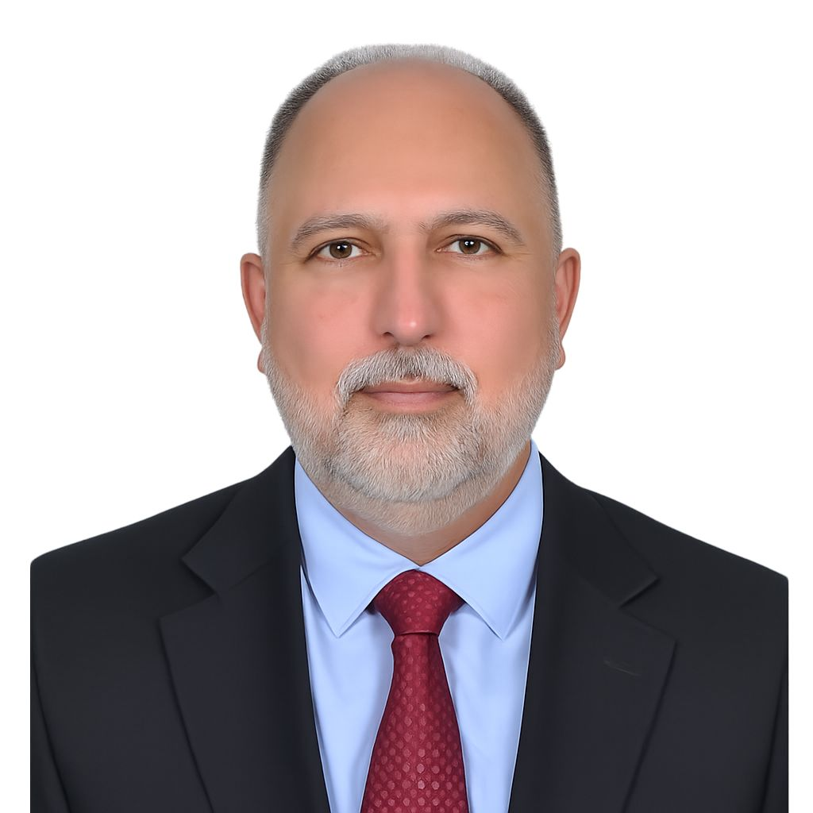

Expert Trainer & Senior Coach: Hisham Nabi
Senior Consultant | Business Mentor | Executive Leadership Coach
Hisham Nabi is a Senior Management and HR sConsultant and a Certified Assessor with over 20 years of experience in the Middle East. He specializes in human capital transformation, leadership development, talent management, and assessment centers. Hisham has a proven track record of driving organizational development across startups, established corporations, and public, private, and semi-governmental sectors.

Key Clients & Sectors
Spanning aviation, telecom, finance, and non-profits, his prominent clients include:
- Government & Sovereign: Public Investment Fund (PIF), ZATCA, Mysk Foundation, and the Ministries of Foreign Affairs, Finance, Housing, and Communications.
- Telecom & Banking: STC, Mobily, Omantel, Al Rajhi Bank, and Saudi National Bank (SNB).

Core Expertise
- Human Capital Transformation & Organizational Development
- Talent Management, Sourcing, & Acquisition
- Establishing Assessment & Development Centers
- Executive, Career, & Leadership Coaching
- Competency-Based Interviewing & Psychometric Assessments

Credentials & Certifications
- Education: Postgraduate Diploma in Business Administration, University of Liverpool.
- Assessments: Certified Professional Assessor (BPS & EFPA); Certified Practitioner in Hogan, Saville, and Korn Ferry.
- Coaching: Certified Life, Career, and Executive Coach (Goal Imagery Institute).
Hisham is a member of the Leadminds expert network, serving as a consultant, business mentor, and executive leadership coach.

Client Portfolio
LeadMinds’ leadership and expert network has contributed to capability-building, assessment Centers, leadership development, HR transformation, certification preparation, and strategy-related engagements across leading organizations in Saudi Arabia and the GCC.
For accuracy and transparency, this section represents organizations served through LeadMinds leadership, expert delivery assignments, previous leadership roles, associate projects, and professional consulting partnerships.

Government & Public Sector
- Saudi Food & Drug Authority — SFDA
- Saudi Data & Artificial Intelligence Authority — SDAIA
- Ministry of Health — Saudi Arabia
- Ministry of Investment — MISA
- Ministry of Defense — UAE
- Department of Government Enablement — DGE, UAE
- Digital Government Authority — DGA, Saudi Arabia
- General Authority of Civil Aviation — GACA
- Human Rights Commission
- National Debt Management Center — NDMC
- Communications, Space & Technology Commission — CST

Financial & Regulatory Sector
- Central Bank of Qatar
- Arab National Bank — ANB
- Kuwait Finance House — KFH
- Saudi Payments

Investment, PIF & National Projects
- Nupco
- Sports Boulevard Foundation — SBF
- Cruise Saudi
- Saudi Investment Recycling Company — SIRC
- Riyadh Airports

Corporate & Private Sector
- Saudi German Health Group — SGH
- Emaar Real Estate Development
- Rezzayat Group
- Savola Group
- Al-Sulaiman Group / Hanco Holding
- Americana KSA

Consulting & Professional Services Partners
- PwC
- Mercer
- Korn Ferry
- Basqaat
- Tharwa
- Morgan International

Start Your Capability Journey
Every organization has different goals, people challenges, and capability gaps.
That is why LeadMinds starts with a conversation, not a catalogue.
We invite you to a 30-minute Capability Discovery Session to explore:
- What capabilities your HR team or leaders need now.
- Which certification or development path fits your people.
- Where strategy execution may be losing momentum.
- How training, coaching, and mentorship can support your 2026 goals.
- What learning journey would create the most practical impact.
Let’s map the gap. Build the capability. And move from training to real performance.

Contact Information
Email: Info@leadmindsgroup.com
Phone: [Insert Phone]
Whatsapp:
Website: www.leadmindsgroup.com
LinkedIn: [Insert LinkedIn]
Location: [Insert Location]
Digital access: A QR code for direct access to the website or contact method.

Thank you!
Professional HR Certification Preparation | Specialized Programs | Strategy Activation & Performance Alignment | Leadership Development | Executive Coaching & Mentorship
LeadMinds — Empowering Minds.. To Lead Transformation..

